**GOVERNMENT COLLEGE OF ENGINEERING ERODE**



B.E Electronics and Communication Engineering

TAMILNADU[TN] MARGINAL WORKERS ASSESSMENT

**Name of the Students: University Register no:**

**Team Leader:**

Karthick Raj . M 731121106021

**Team Members:**

Aatham Ansari . B 731121106001

Selvaragavan . K 731121106042

Senthamil Selvan . V 731121106043

Gowtham . R 731121106016

Under the mentor of

**Dr.M.Sathiyakala**

**Department of Information Technology(IT)**

**Department of Electronics and Communication Engineering**

Government College of Engineering

Erode ,PO ,near Vasavi College,TamilNadu-638316,

Affiliated to Anna University ,Chennai.

**TAMILNADU[TN] MARGINAL WORKERS ASSESSMENT**

**Project Introduction:**

The project involves analysing the demographic characteristics of marginal workers in Tamil Nadu based on their age, industrial category, and sex. The objective is to perform a socioeconomic analysis and create visualizations to represent the distribution of marginal workers across different categories. This project includes defining objectives, designing the analysis approach, selecting appropriate visualization types, and performing the analysis **using Python and data visualization libraries.**

**Objectives:**

**Identification of Marginalized Groups:**

To identify specific marginalized groups within the marginal worker population, such as women, Scheduled Castes, Scheduled Tribes, and other vulnerable **communities.**

**Economic and Social Indicators:**

To assess the economic well-being of marginal workers by measuring income levels, wage disparities, and access to social security benefits.

To evaluate the living conditions, healthcare access, and education status of marginal workers and their families.

**Labor Rights and Welfare Programs:**

To examine the extent to which marginal workers are aware of their labour rights and the utilization of existing labour welfare programs.

To identify barriers that prevent marginal workers from accessing and benefiting from these programs.

**Design Thinking:**

* 1. Project Objectives: Define objectives such as analysing marginal worker demographics, understanding age and gender distribution, and exploring industrial categories.
  2. Analysis Approach: Plan the steps to extract, clean, and analyse the dataset to derive insights.
  3. Visualization Selection: Determine suitable visualization types (e.g., bar charts, pie charts, heatmaps) to represent demographic distributions effectively.

**Visualization:**

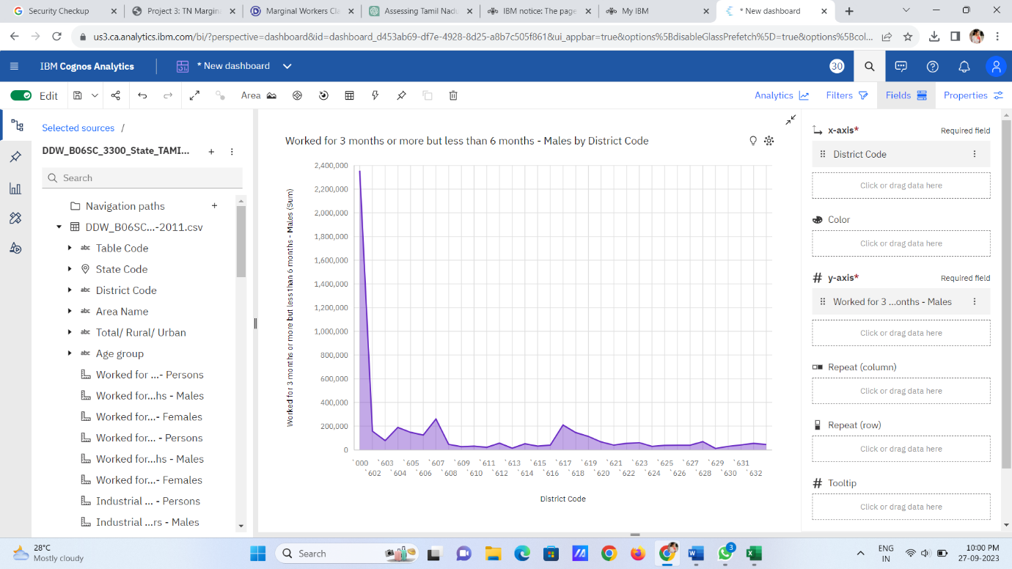

**Conclusion:**

The Tamil Nadu Marginal Workers Assessment project has been a comprehensive examination of the working and living conditions of marginal workers in the region. Through rigorous data collection, analysis, and engagement with stakeholders, we have gained valuable insights into the challenges and opportunities faced by this vulnerable population**.**